One Click

Database class project 2021/2022

|  |  |  |  |  |
| --- | --- | --- | --- | --- |
| Student Name in English | Student Name in Arabic | Student ID | Section | Work percentage |
| Sundos saifi | سندس مصطفى صيفي | 11924204 | Sun/wed8-9:30 | 50% |
| Yaqeen Yaseen | يقين محمد ياسين | 11924311 | Mon/thur 9:30-11 | 50% |
|  |  |  |  |  |

Date/time

---------------------------------------------This section is intended for the Instructor---------------------------------------

|  |  |
| --- | --- |
| **Topic** | **Mark** |
| Project Requirements and Modeling |  |
| Correctness of Database mapping |  |
| Functional Dependency and Normalization |  |
| Project Tools |  |
| Project Discussion |  |
| Project Completeness |  |
| Project Output Results or reporting (JasperReport, charts, graphs, etc.) |  |
| Project Administration and Management |  |
| Project Report |  |
| Project Idea |  |
| Project Complexity |  |
| Team work |  |
|  |  |
|  |  |
|  |  |

**Abstarct:**

After a lot of thinking we chose our idea between many ones, we decided to make an app that would help people through their journey to Turkey, we named this app One Click , the name of our app is inspired of the idea that each operation you do in our app requires you one click and you will be ready to go.

This app was interested in helping users through their journey to Turkey specifically ,because many Palestinians visit turkey every year.

Admins of this app will be in control of users information by adding or deleting ,and they will be in charge of displaying, adding and deleting data for the services that we provide the users with in this app.

**Table of content:**

Introduction ……………………………………………..4

Project Requirements…………………………………5

Functional Dependency : ……………………………6,7,8,9

Normalization………………………………………………9

uml………………………………………………………………10

Tools used for Project……………………………………11

Gui…………………..12,13,14,15,16,17,18,19,20,21,22,23,24,25,26

References …………………………………………………….27

Conclousion……………………………………………………..28

**Introduction:**

Many people face a lot of problems and challenges when they want to visit any country ,they sometimes have no idea where to go, which cities to visit, what restaurants or hotels to choose ,and how to travel around the country, So we wanted to help.

We came with this idea that will help the traveler solving these problems when visiting turkey.

This app will help the users in choosing and booking for their journey, we provide the users with many features that could help them ,they can see their profile page and what they chose or booked and they can recover their password if they forget it by sending it to their email.

In the end ,The admin will be able to be provided with reports from the system any time he asks for one.

**Project Requirements:**

-One click is an application in order to help the user organize his trip to turkey.

The system is organized into: -

1-Users consists of SSN(unique), user name, User date of birth, country ,user email ,user password, profile picture, Type(admin ,user). each user will be able to see information and make reservations in several cities of turkey.

2-Cities consists of city name ,city id(unique),picture ,gif picture, description, each city will show the user four choices( touristic places ,restaurants ,cars ,hotels) and the user will put a reservation of a city he choose.

3-Cars consists of car id(unique), name, price, color, type , a collection of pictures , some of these cars will be reserved cars.

4-Restaurants consists of restaurant id(unique), name, Location ,Description ,Picture.

5-Touristic places consists of touristic_id(unique), name,location ,pictures , general description.

6-Hotel consists of Hotel_id(unique), name ,location, picture, Rate, some of the hotels will be reserved by users(reserved hotels).

7-Reservation consists of Reservation ID, Reservation date, Hotel flag,

Car flag, reservation could be Reserved cars

Functional Dependency :

**1- USERS Table :**

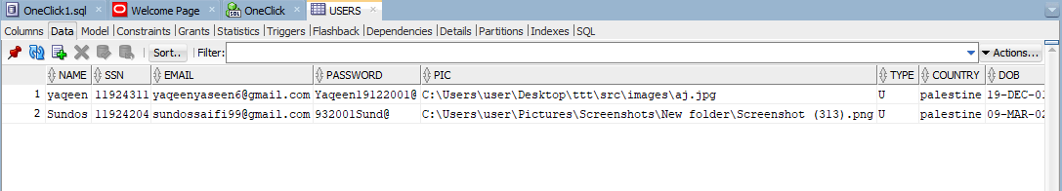

* Functional Dependency For USERS Table:

1- SSN —> NAME 8-EMAIL —>NAME

2- SSN —> EMAIL 9- EMAIL —>PASSWORD

3- SSN —>PASSWORD 10- EMAIL —>SSN

4- SSN —>PIC 11- EMAIL—>PIC

5- SSN —>TYPE 12- EMAIL —>TYPE

6- SSN —>COUNTRY 13- EMAIL —>COUNTRY

7- SSN —>DOB 14- EMAIL —>DOB

____________________________________________________

2- CITY Table :

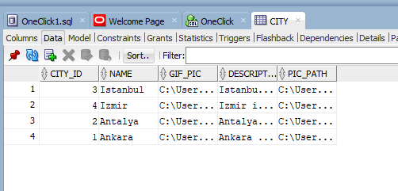

* Functional Dependency For CITY Table:

1- CITY_ID —>NAME 5- NAME —> CITY_ID

2- CITY_ID —>GIF_PIC 6- NAME —> GIF_PIC

3- CITY_ID —>DESCRIPTION 7- NAME —> DESCRIPTION

4- CITY_ID —>pic_path 8- NAME —> pic_path

9- GIF_PIC —>NAME 13- DESCRIPTION —> CITY_ID

10- GIF_PIC —> CITY_ID 14- DESCRIPTION —> GIF_PIC

11- GIF_PIC —>DESCRIPTION 15- DESCRIPTION —> NAME

12- GIF_PIC —>pic_path 16- DESCRIPTION —> pic_path

17- pic_path —>NAME

18- pic_path —> CITY_ID

19- pic_path —>DESCRIPTION

20- pic_path —> GIF_PIC

________________________________________________________

3- CAR Table :

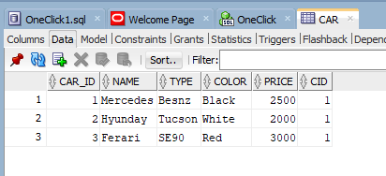

* Functional Dependency For CAR Table:

1- CAR_ID —>NAME 5- CAR_ID —> CID

2- CAR_ID —>TYPE 6- CarPICS—> CAR_ID

3- CAR_ID —>COLOR 7- TYPE—> NAME

4- CAR_ID —>PRICE

4- Hotel Table :

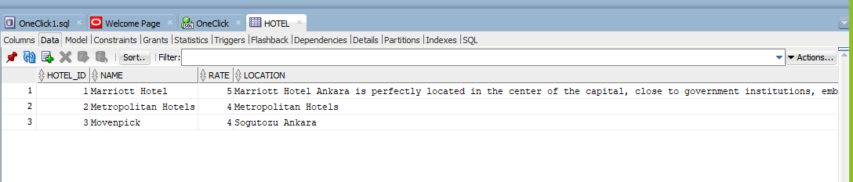

* Functional Dependency For HOTEL Table:

1- HOTEL_ID —>NAME 5- HOTEL _ID —> CID

2- HOTEL_ID —>RATE 6-PIC—> HOTEL _ID

3- HOTEL_ID —> LOCATION 7- CID—> LOCATION

4- HOTEL _ID —>PIC

5- RESTAURANTS Table :

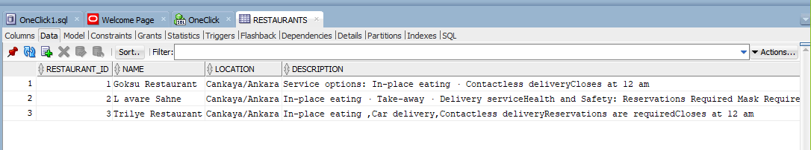

* Functional Dependency For RESTAURANTS Table:

1- RESTAURANTS _ID —>NAME 5- RESTAURANTS _ID —> DESCRIPTION 2- RESTAURANTS _ID —>CID 6-PIC—> RESTAURANTS _ID

3- RESTAURANTS _ID —> LOCATION 7- CID—> LOCATION

4- RESTAURANTS _ID —>PIC

6- TOURISTIC_PLACE Table :

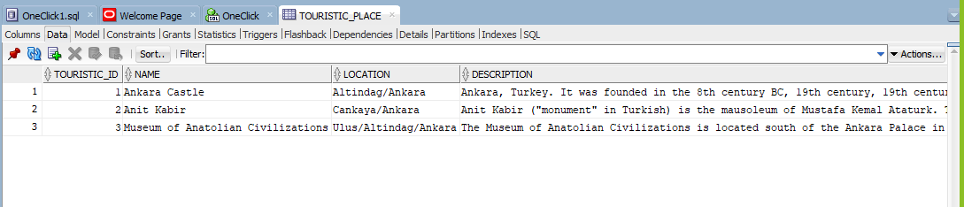

* Functional Dependency For TOURISTIC_PLACE Table:

1- TOURISTIC_ID —>NAME 5- TOURISTIC_ID —> DESCRIPTION 2- TOURISTIC_ID —>CID 6-PICS—> TOURISTIC_ID

3- TOURISTIC_ID —> LOCATION 7- DESCRIPTION —> TOURISTIC_ID

4- CID —> LOCATION

___________________________________________________

7- RESERVATION Table :

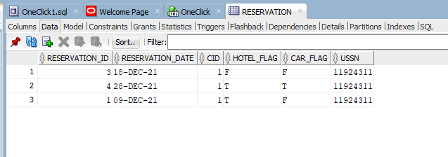

* Functional Dependency For RESERVATION Table:

1- RESERVATION_ID —> RESERVATION_DATE

2- RESERVATION_ID —> HOTEL_FLAG

3- RESERVATION_ID —> CAR_FLAG

4- RESERVATION_ID —> USSN

5- RESERVATION_ID —> CID

6- RESERVATION_DATE —> USSN

**Normalization:**

1-Car table has a problem(nested relations),this problem occurs because the car has a collection of pictures

To solve this problem we make a table for pictures only this table has a primary key ,the primary key of cars table as a foreign key and a cars picture attribute

2- touristic places table has a problem(nested relations),this problem occurs because the touristic places has a collection of pictures

To solve this problem we make a table for pictures only this table has a primary key ,the primary key of touristic places table as a foreign key and a touristic places picture attribute



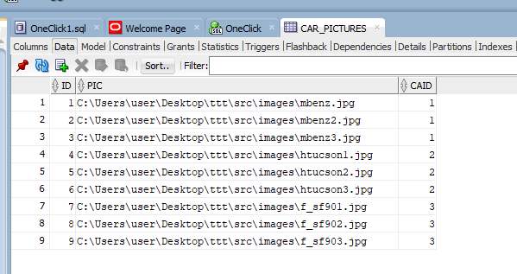

**UML Diagram:**

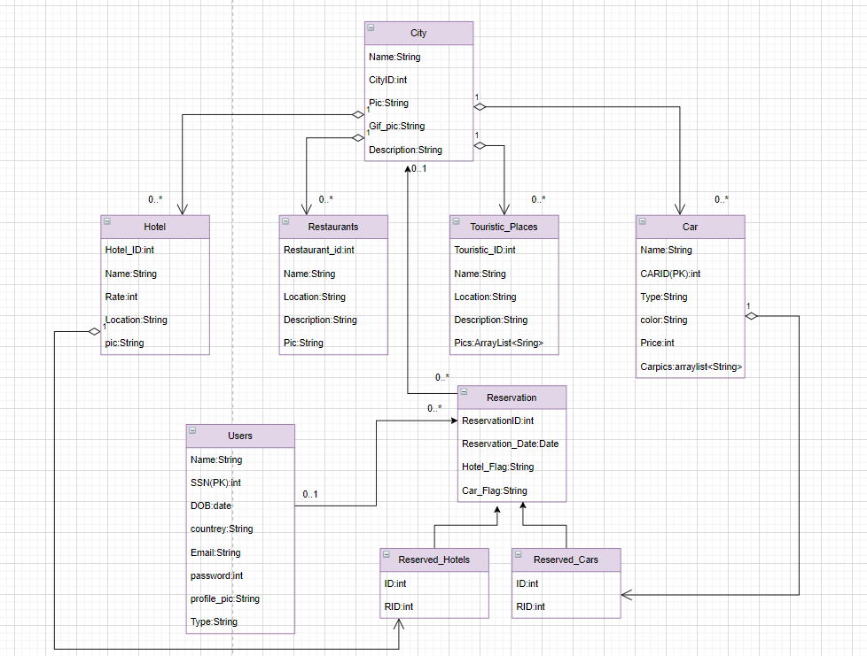

**The diagram we generated for our project from sql developer:**

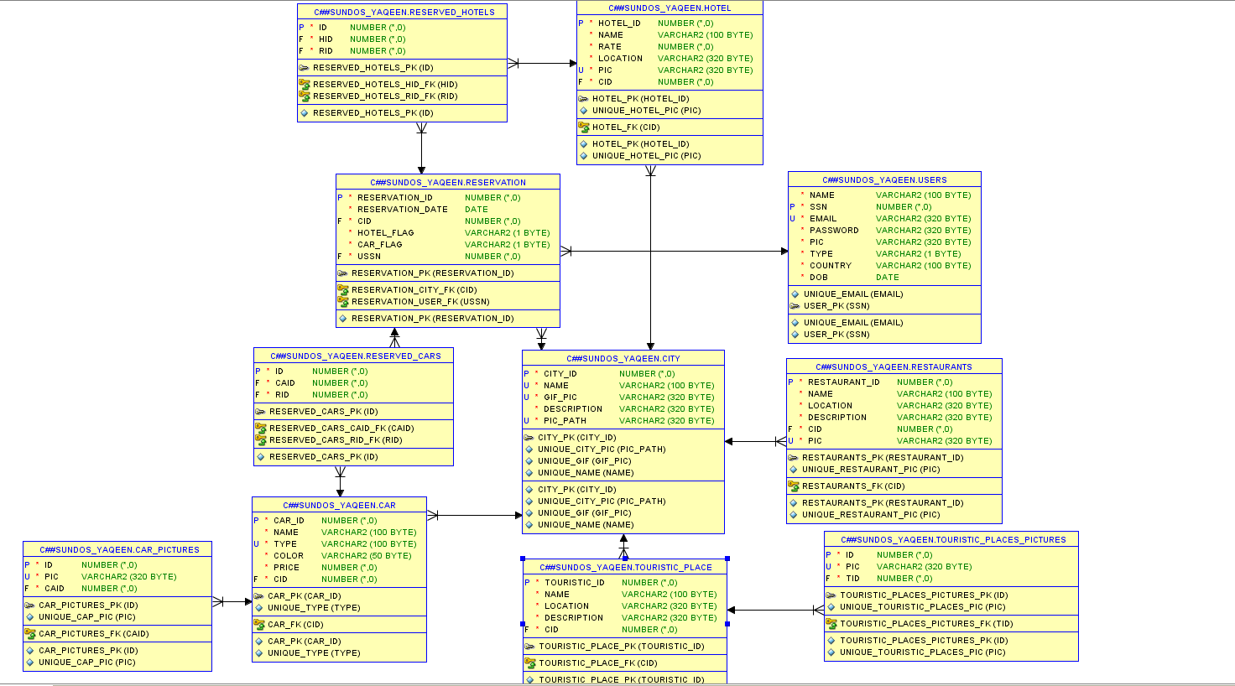

**Tools used for Project:**

1-IntelliJ IDEA Community Edition 2021.1.2 x64

2- SQL Developer

3-Draw.IO

4-Jasper soft studio for jasper report.

5-Scene Builder for creating the FXML files used inside the JavaFX Project.

6-CSS for styling the interfaces in JavaFX.

­7-Word documents.

8-Text documents.

9-Oracle 18c.

**GUI Discussion:**

Log IN Frame:

This is a sliding screen that the user use it to choose if he wants to create a new account from sign up button or enter an existing account from sign in button.

This is what the user get when he clicks on sign up.

The user must fill all the fields and some fields have some restrictions like password(it must contain capital & small letters and special characters)

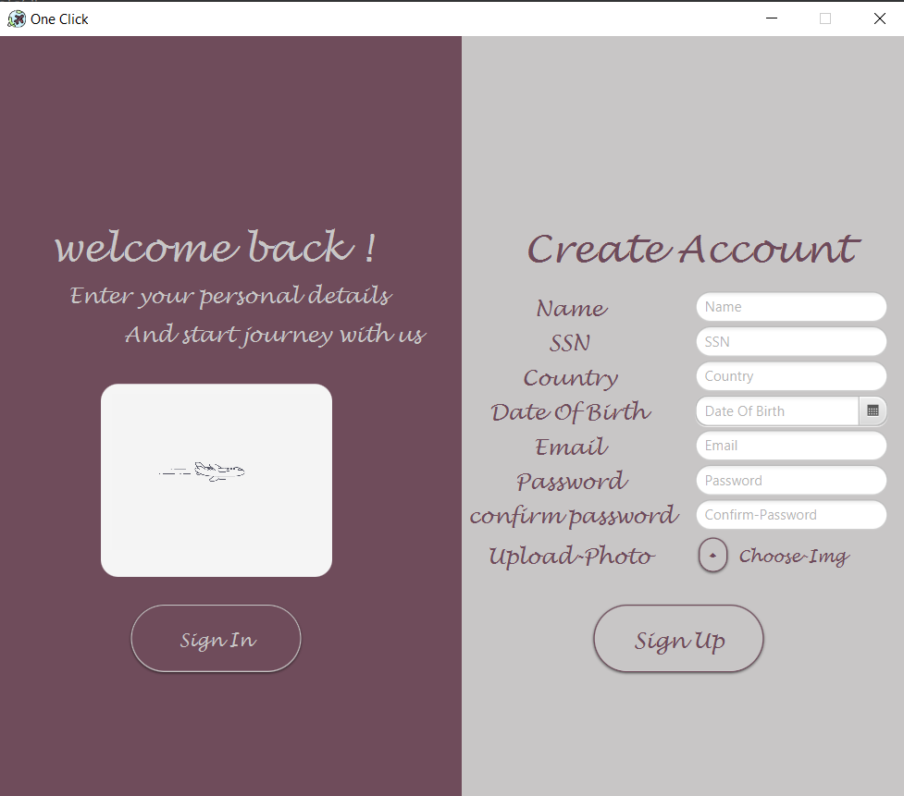

The screen will slide and show the user sign in scree when he clicks sign in

button.

And there is a button that gives you the opportunity to show your password

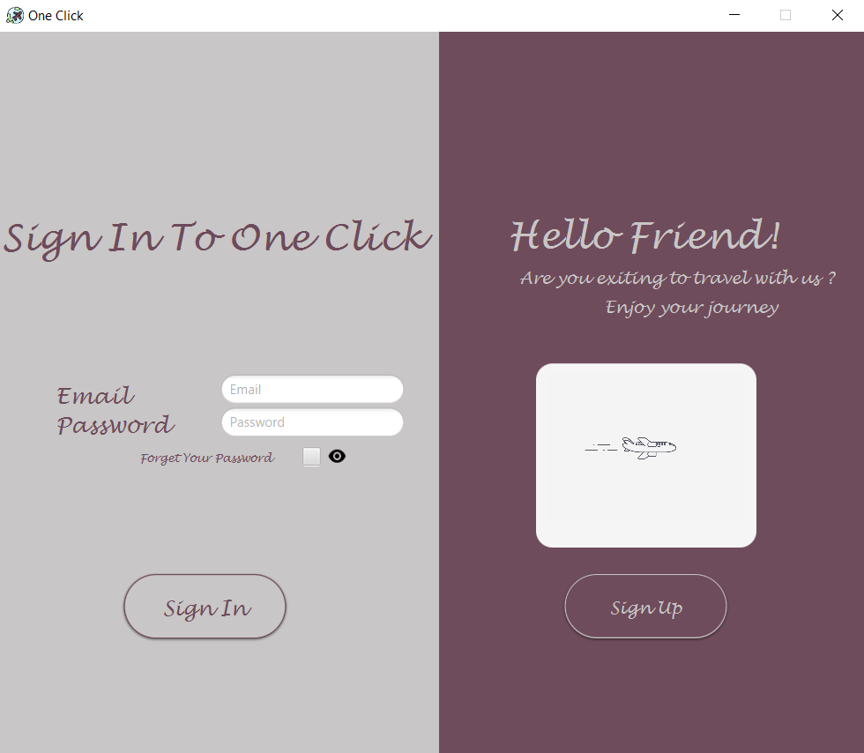

And if the user forget his password he can recover it from button(forget your

password) an email will be send to the user with his password

This dialog will occurs when user click(forget your password)

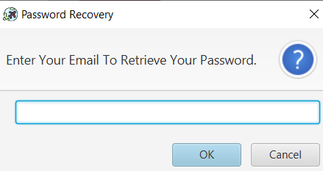

This email will be send to the user with his password

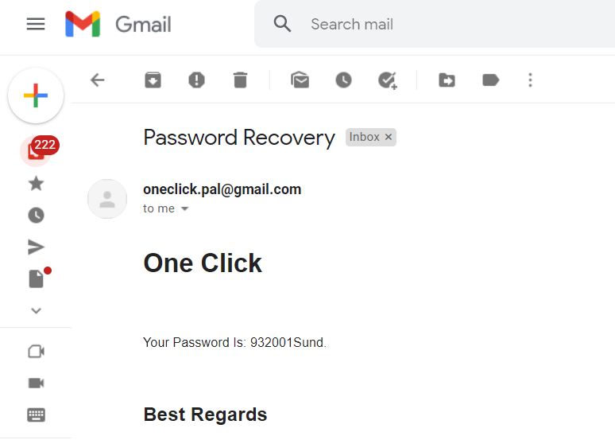

If the user is already registered and has entered both the email and password correctly, a loading animation will occurs.

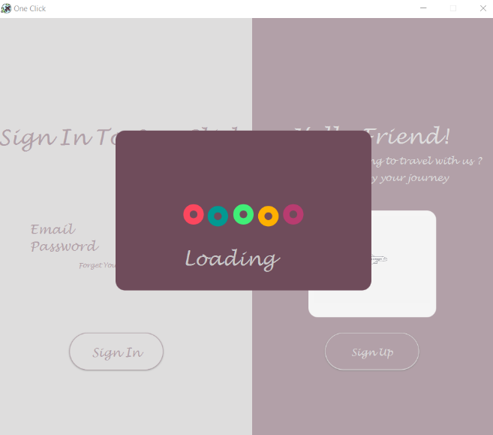

then this screen will occurs.

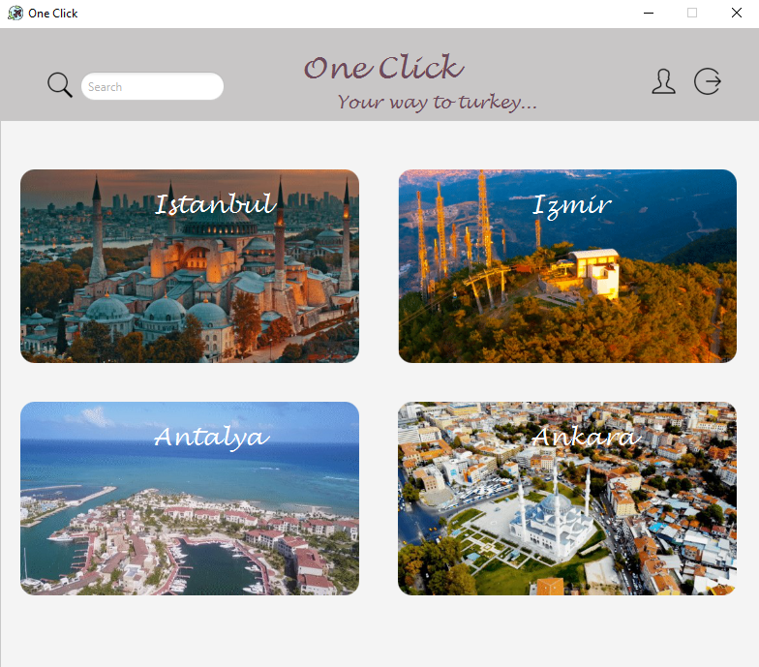

In this screen the cities will occurs and there is 3 more buttons (Search, profile ,sign out) .search button is used to search for a city, profile button is to let the user enter his account , and the sign out button to logout from the account

when we enter the mouse on the city an animation is loaded .

After choosing a city this screen will occurs.

This screen gives the user the opportunity to choose from five buttons(Hotels, Cars, Restaurants ,Touristic Places, Book) and there is a home button to go to the previous screen(Cities screen).

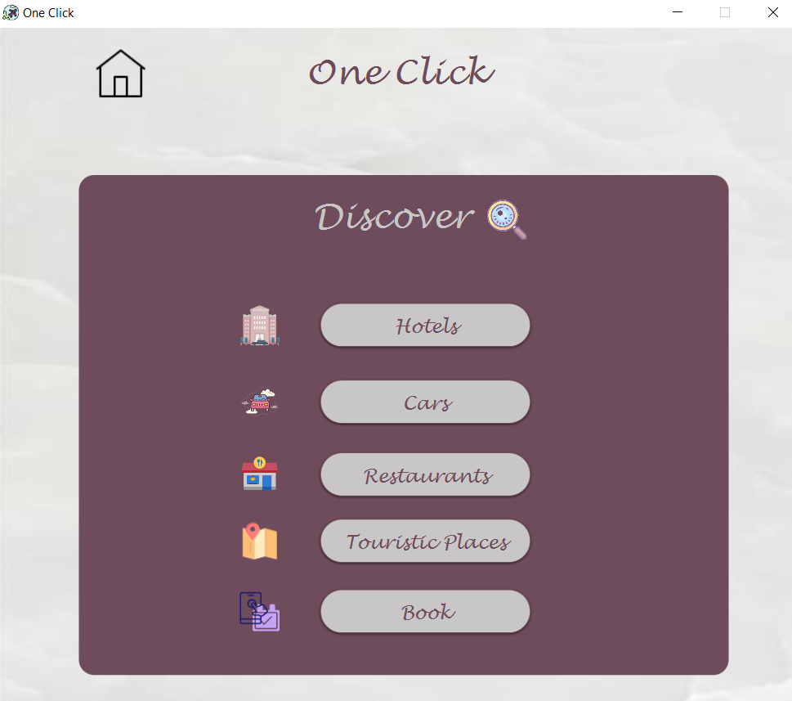

When the user click on hotels this screen will occurs

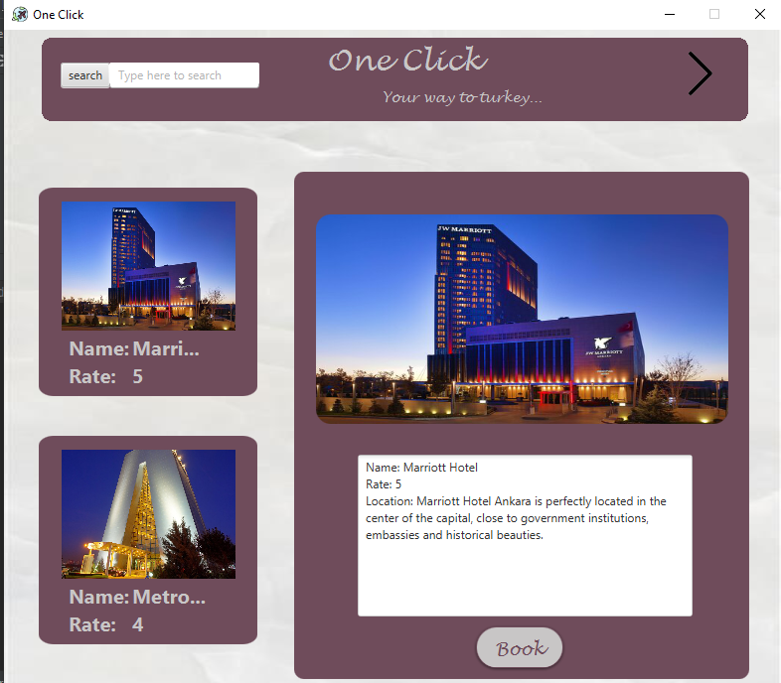

This screen will show all available hotels on the left and when the user choose a hotel the pane on the right will occurs ,this pane shows the picture and has a text area in which information about the hotel will occur.

There is three more buttons(search, previous ,book).

Search( to search about a hotel)

Previous(to go back for the previous screen which have the buttons to show info from)

When we enter book button this alert message will occurs to book a hotel.

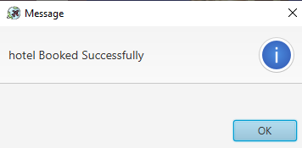

When the user click on cars this screen will occurs

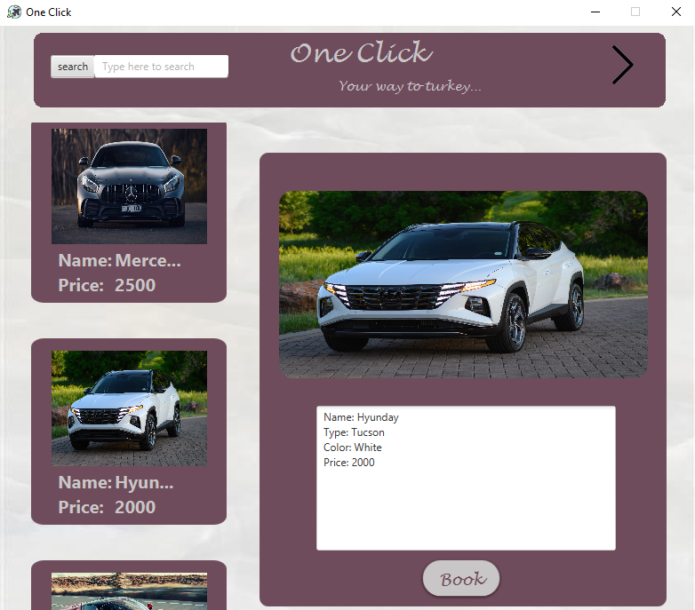

This screen will show all available cars on the left and when the user choose a car the pane on the right will occurs ,this pane shows the picture and has a text area in which information about the car will occur.

There is three more buttons(search, previous ,book).

Search( to search about a car)

Previous(to go back for the previous screen which have the buttons to show info from)

When we enter book button this alert message will occurs to book a car.

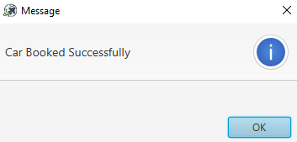

When the user click on restaurants this screen will occurs

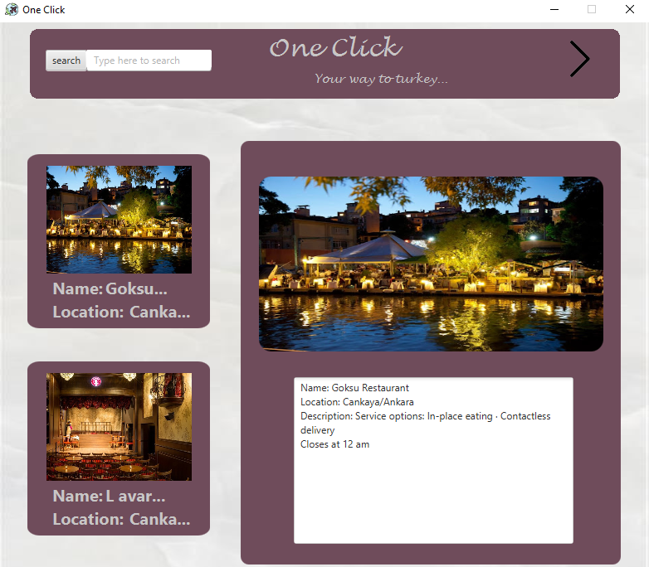

This screen will show some recommendations of restaurants on the left and when the user choose a restaurant the pane on the right will occurs ,this pane shows the picture and has a text area in which information about the restaurant will occur.

There is two more buttons(search, previous ).

Search( to search about a car)

Previous(to go back for the previous screen which have the buttons to show info from)

When the user click on touristic places this screen will occurs

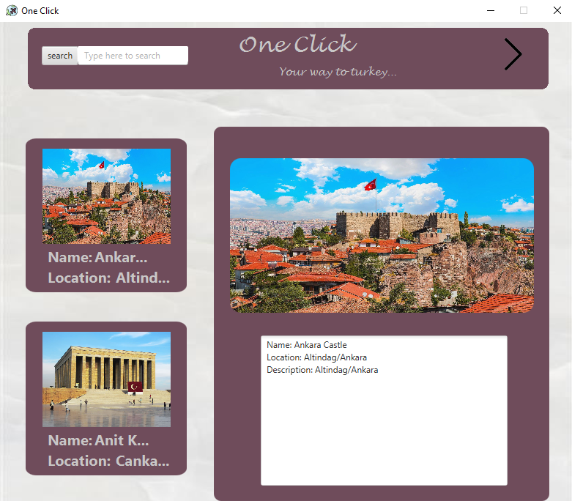

This screen will show some recommendations of touristic places on the left and when the user choose a touristic place the pane on the right will occurs ,this pane shows the picture and has a text area in which information about the touristic place will occur.

There is two more buttons(search, previous ).

Search( to search about a car)

Previous(to go back for the previous screen which have the buttons to show info from)

When the user click on book this dialog will occurs to book the users resarvations of the city on a specific date.

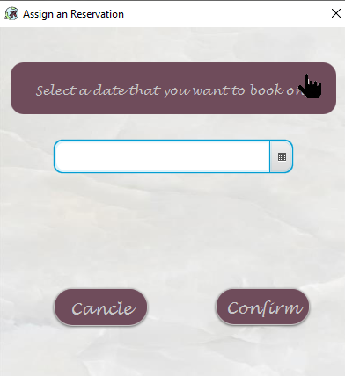

When the user click on confirm this alert message will occur.

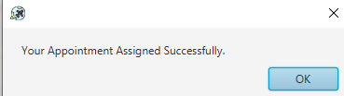

When the user click on profile button in cities screen this screen will occurs

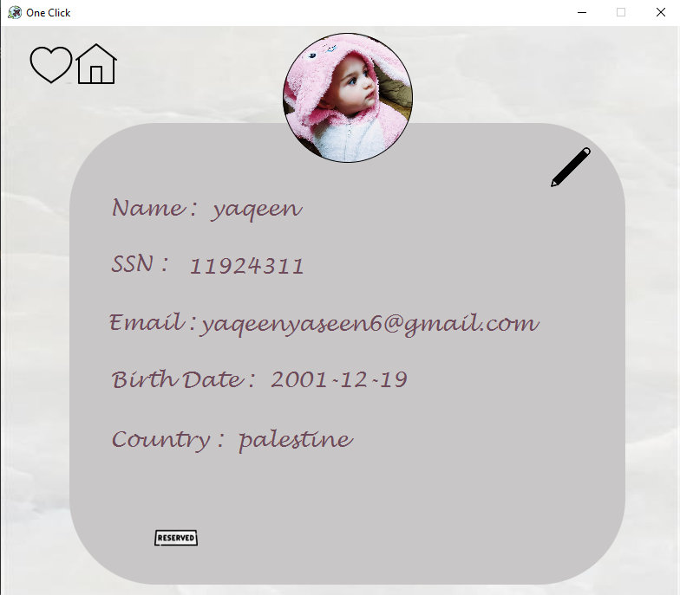

This screen will show user info and three buttons(home,edit,reserved)

Home will make you go back to cities screen

And when the user click on reserved this screen will occurs

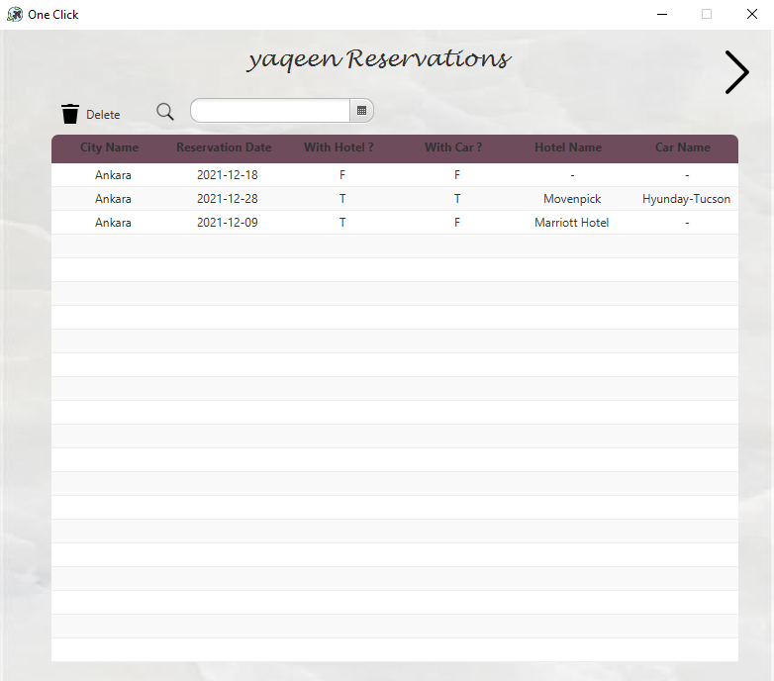

This screen shows all resarvations the user did and has a search button to search for specific date and delete button to delete a reservation, and back button to go back for profile screen

When the user click on edit in the profile screen this screen will occurs

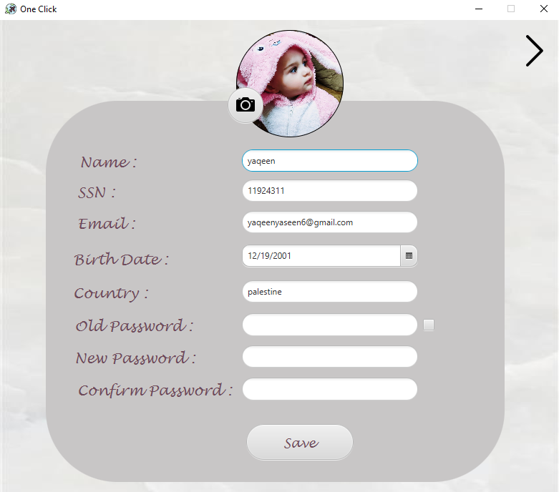

This screen allows the user to edit what ever he wants from his info.

When we click save this alert message will occurs

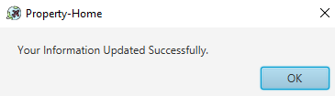

**Admin Screen:**

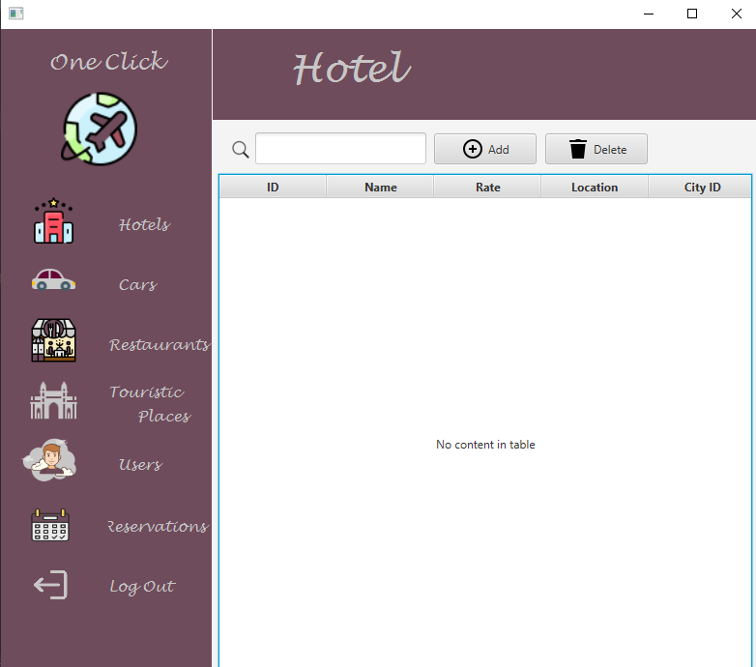

This screen will give the admin Access Permissions for hotels ,cars, restaurants ,touristic places, all resrvations, and users

What ever button we click a pane that contains a table of the information will occurs and a search field and and an add button to add info and delete button to delete info.

**Refrences:**

1-Stack OverFlow

<https://stackoverflow.com/>

2-Oracle Help Centre

<https://docs.oracle.com/en/>

3-button design:

http://fxexperience.com/2011/12/styling-fx-buttons-with-css/

4-icon8

<https://icons8.com/>

5-color palett

https://colorhunt.co/?fbclid=IwAR3Ek3aTRNbYFmaYzhXAreZsZq9SxkDl7UTFm-RPs3UpBF652MTiX874sOU

6-gif editer

<https://onlinegiftools.com/change-gif-background-color>

**Conclusion:**

This application helps its users through their journey to turkey , it also make it easier for admins to control information in the data base ,and information of the users.